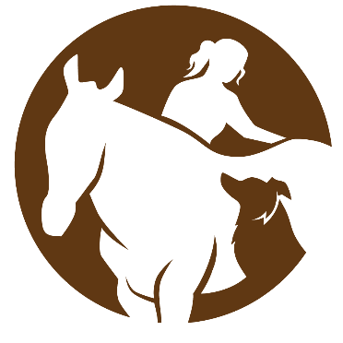Optimal Equine & Canine Massage Clinic
Please join us Saturday, January 10th at Madison Ranch and Equine to learn about the impacts of Equine Massage therapy and how the muscular system works to move the equine body!
- View muscles in motion and a demonstration of massage techniques to release tight fascia and muscles in the horse.
- Identify behaviors horses exhibit to communicate muscle tension and releases
- Learn key stretches to do with your horse to prevent injury and check range of motion
- Practice a massage technique at the end of the day

“Helping Animals Reach their Optimal Potential of Health and Performance through Massage Therapy”
Brienne Vigar|Certified Equine & Canine Massage Therapist| 812-493-5042 | Versailles, IN | optimalequinemassage.com

About Optimal Equine & Canine Massage:
Optimal Equine & Canine Massage was established in 2019 with the mission of “Helping Animals reach their Optimal Health and Performance through Massage Therapy.” Since then, Optimal Equine & Canine Massage has expanded to offer Hoof care, and today, owner Brienne Vigar continues to work toward the same mission through each service today. Massage Therapy services include full body equine and canine massage sessions catered to each unique animal to provide a positive experience. Owners often have specific goals for their animals, including injury prevention or rehabilitation, increased range of motion or mobility, reduced inflammation and recovery time, and activation of the parasympathetic nervous system, or “rest and digest” phase. With the animal’s condition in mind, sessions consist of a variety of sports massage and myofascial release techniques to achieve these goals. Other modalities Optimal Equine & Canine Massage offers include Raindrop Massage Therapy and Pulse Electro Magnetic Field Therapy through the BEMER Equine Set. A few stretches are chosen according to areas of restriction in the animal and are done after the massage. Call me to discuss how these services and benefit your animal, and visit my website at Optimalequinemassage.com for a more in-depth description of services as well as a summary of the courses and certifications I have taken.

